DOCKER – CHALLENGES

Create a customized Docker image using a Dockerfile.
create a working directory
- mkdir docker
- cd docker
2. Create and open Dockerfile
- vi Dockerfile
3. Write content inside Dockerfile
You added this configuration:
FROM amazonlinux:latest

RUN yum update -y && \
yum install -y nginx && \
yum clean all

RUN mkdir -p /usr/share/nginx/html

RUN echo "<h1>Hello from Nginx Docker</h1>" > /usr/share/nginx/html/index.html

EXPOSE 80

CMD ["nginx", "-g", "daemon off;"]
Build the image
- docker build -t test-nginx .

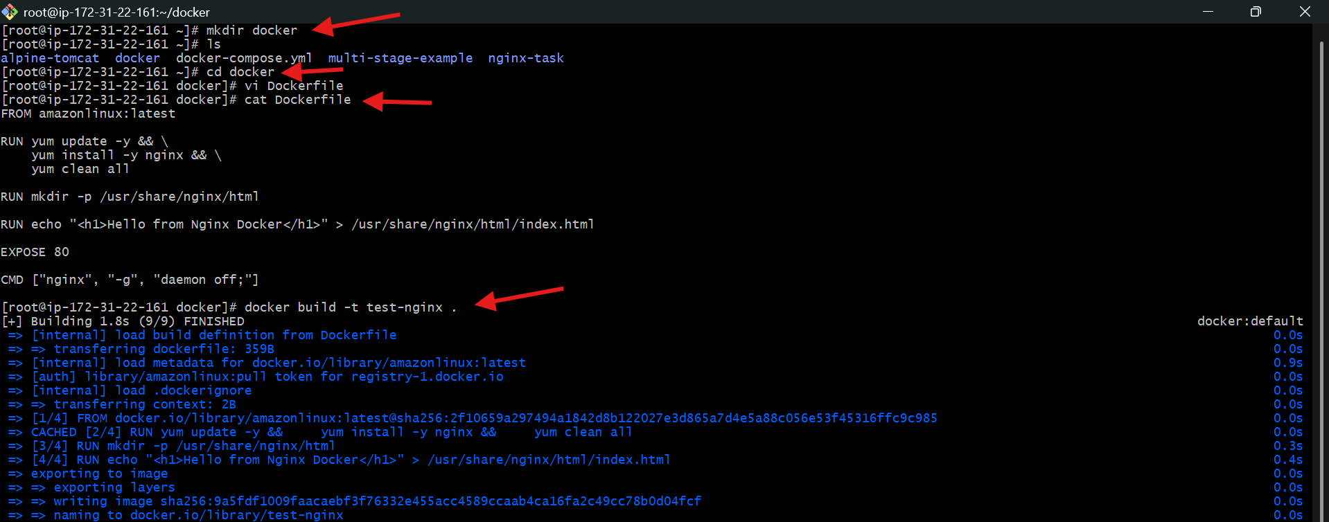
Run container from image
- docker run -itd -p 83:80 test-nginx

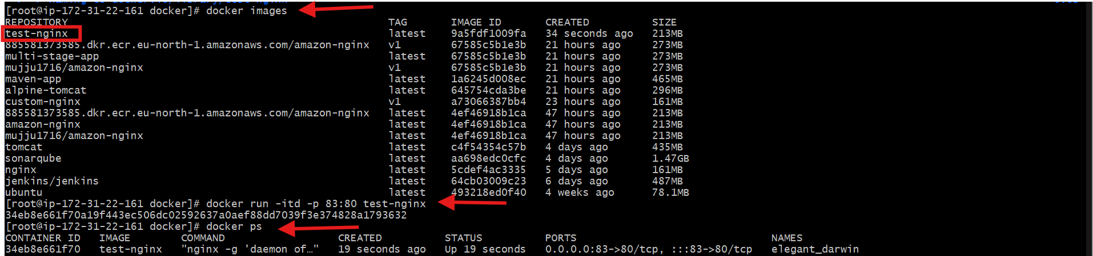
Access application in browser
Open in browser:
http://<EC2-Public-IP>:83

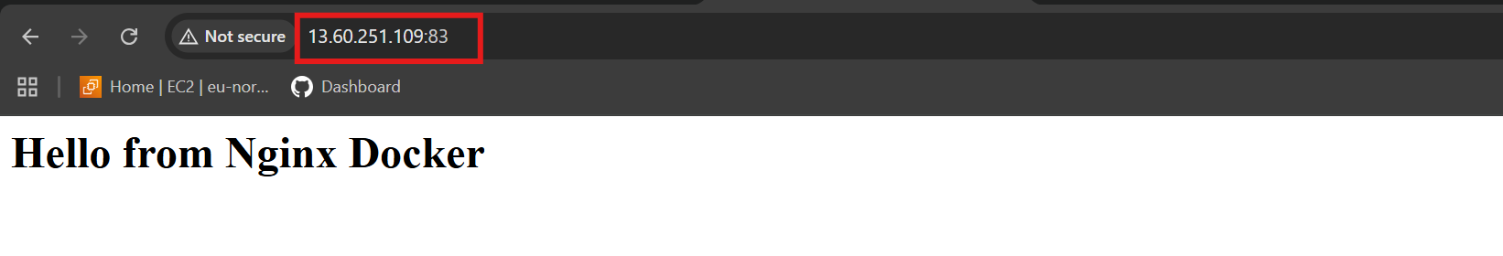

Push the image to Docker Hub.
Login to Docker Hub
- docker login

Tag the Local Image
renamed (tagged) your image with your Docker Hub username:
- docker tag test-nginx muju1716/test-nginx
Format:
- docker tag <local-image> <dockerhub-username>/<repo-name>

Push Image to Docker Hub
- docker push muju1716/test-nginx

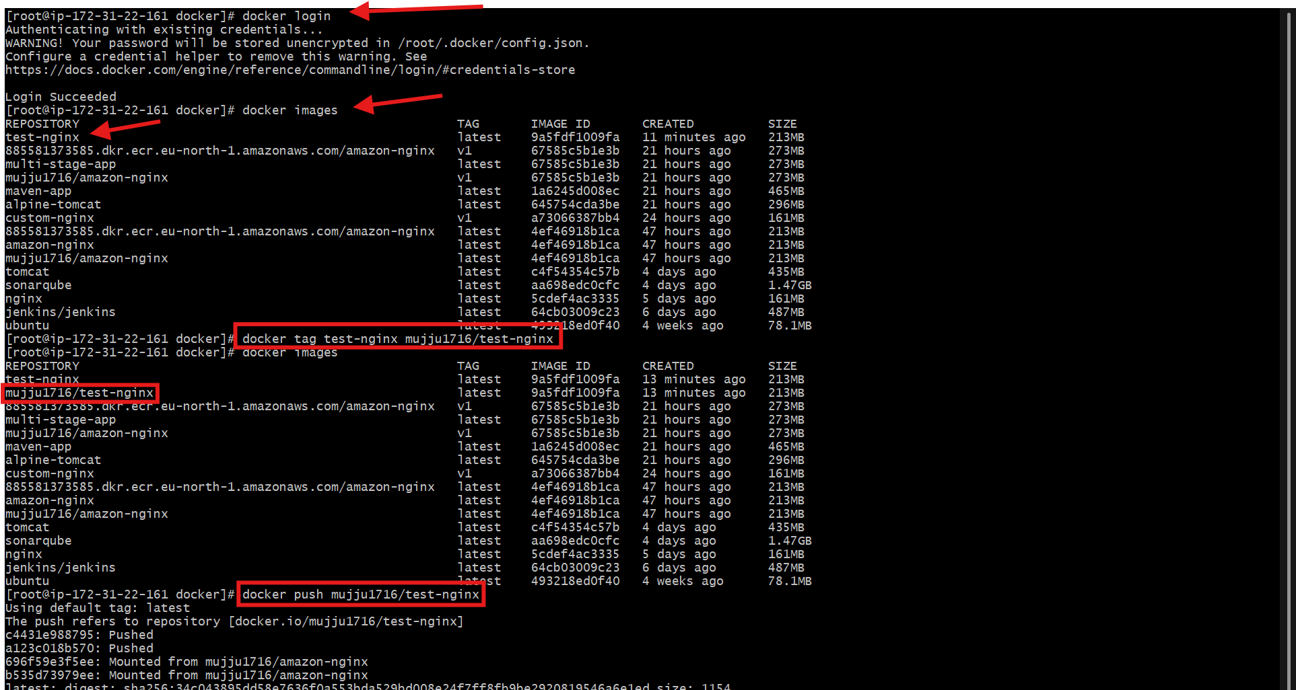

Verify on Docker Hub Website
opened Docker Hub and checked:
muju1716/test-nginx

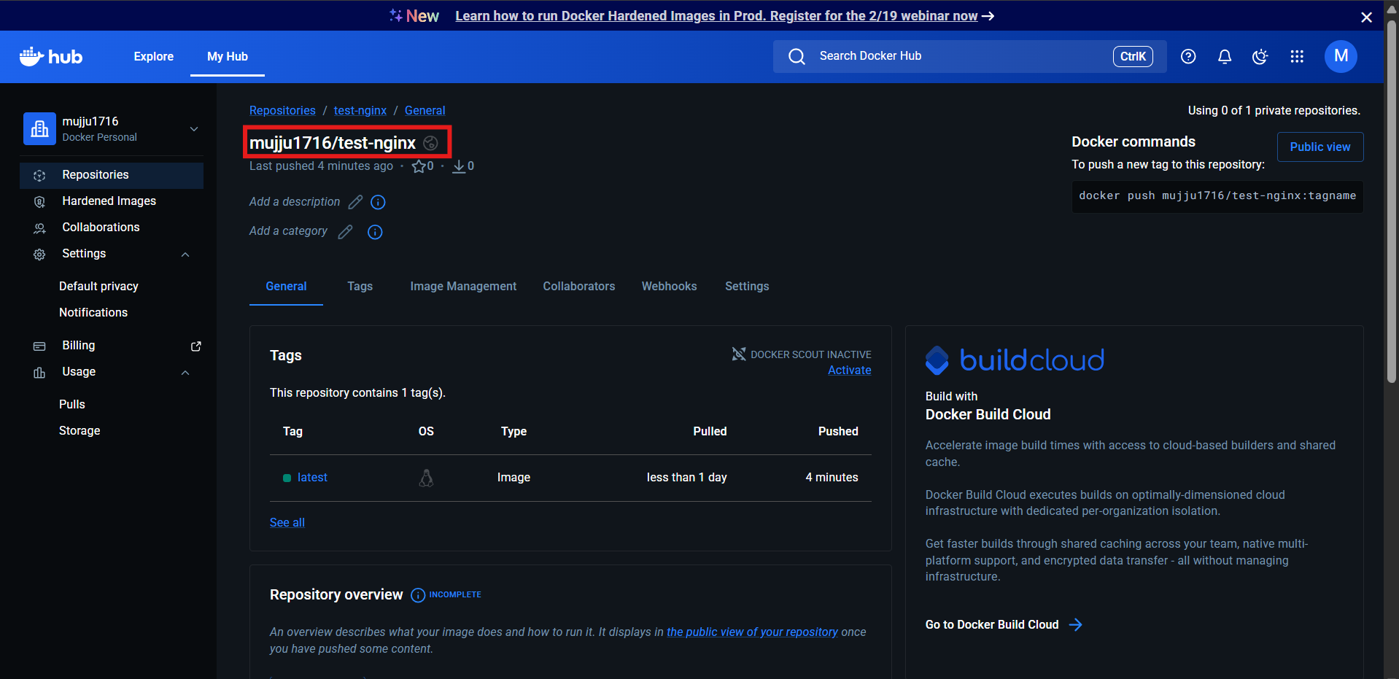

Push the same image to Amazon ECR.

Authenticate Docker with ECR
ran this command:
- aws ecr get-login-password --region eu-north-1 \
| docker login --username AWS --password-stdin 885581373585.dkr.ecr.eu-north-1.amazonaws.com
This connects Docker to AWS ECR registry.

Tag Image with ECR Repository URL
executed:
- docker tag amazon-nginx:latest \
885581373585.dkr.ecr.eu-north-1.amazonaws.com/amazon-nginx:latest
This prepares your image for upload to ECR.
Format:
- docker tag <local-image>:<tag> <aws-account>.dkr.ecr.<region>.amazonaws.com/<repo>:<tag>

Upload Image to ECR
ran:
- docker push 885581373585.dkr.ecr.eu-north-1.amazonaws.com/amazon-nginx:latest

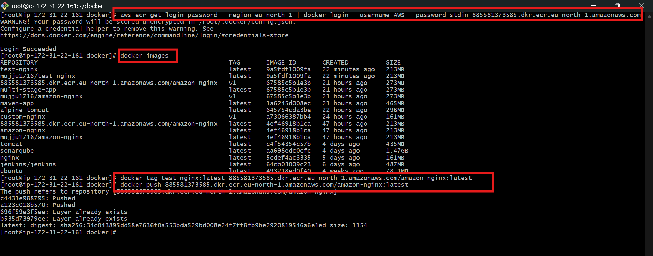
Open AWS ECR → Repositories → amazon-nginx → Images
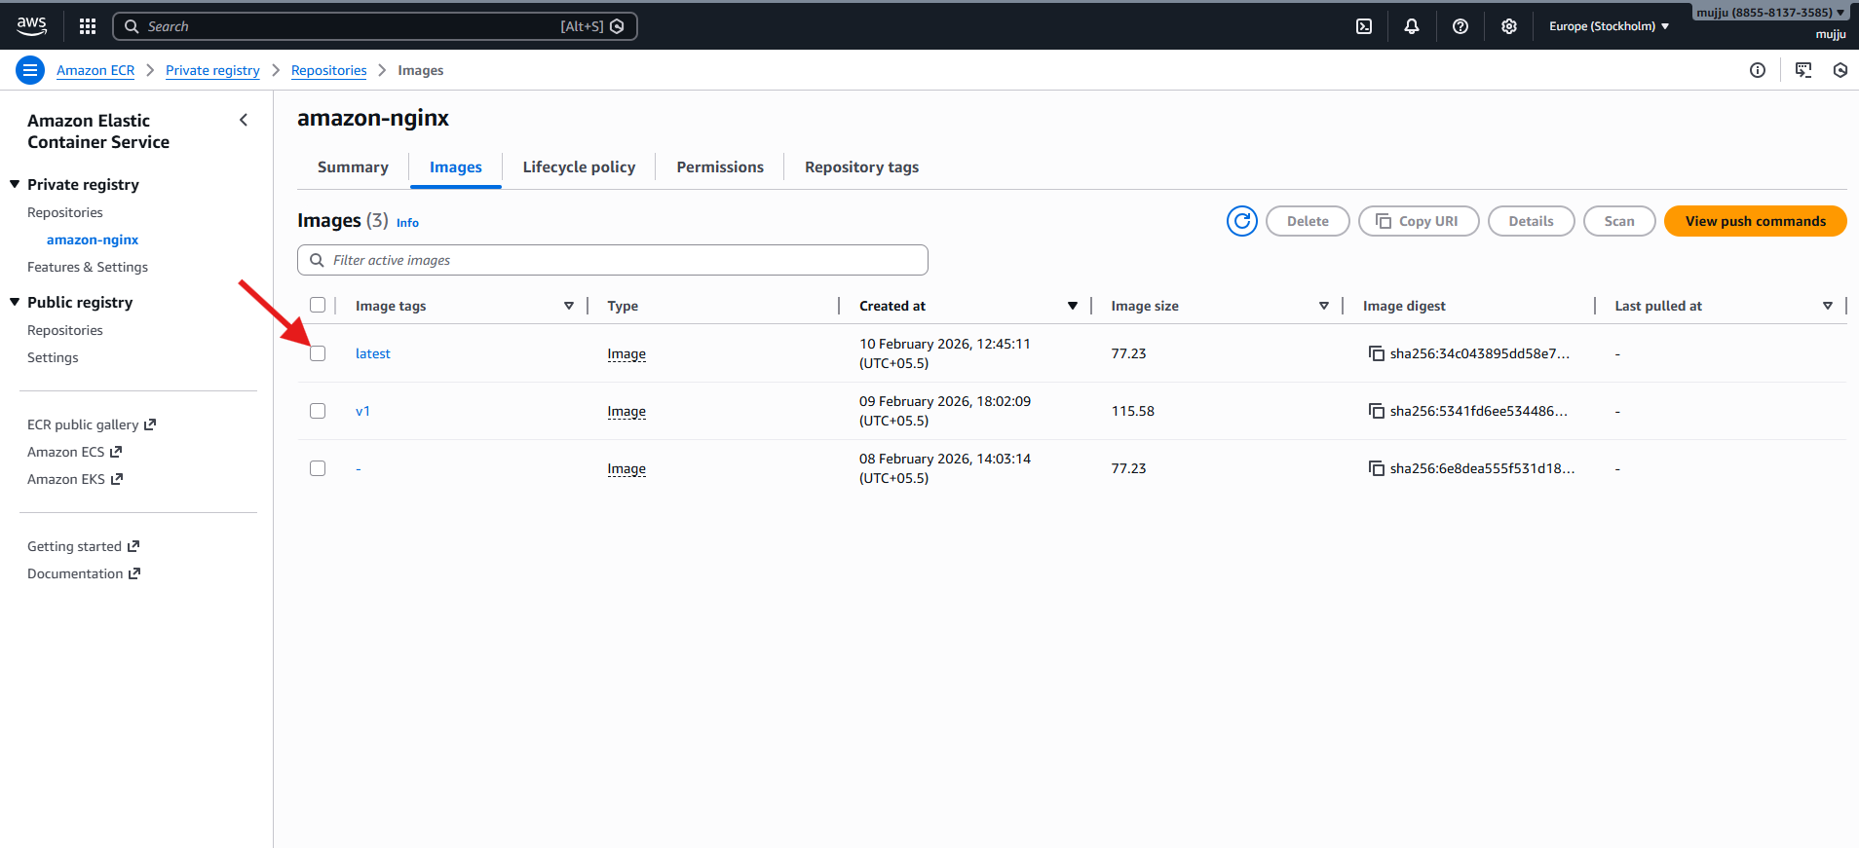

Provision one EC2 instance using Terraform and install Jenkins.
provider "aws" {
region = "eu-north-1"
}

# Key pair name (must exist in AWS)
variable "key_name" {
default = "linux"
}

resource "aws_instance" "jenkins_server" {
ami = "ami-0c83cb1c664994bbd" # Amazon Linux 2 (eu-north-1)
instance_type = "m7i-flex.large"
key_name = var.key_name

vpc_security_group_ids = [aws_security_group.jenkins_sg.id]

user_data = <<-EOF
#!/bin/bash
yum update -y

# Install Java
yum install java-17-amazon-corretto -y

# Add Jenkins repo
wget -O /etc/yum.repos.d/jenkins.repo https://pkg.jenkins.io/redhat-stable/jenkins.repo
rpm --import https://pkg.jenkins.io/redhat-stable/jenkins.io-2023.key

# Install Jenkins
yum install jenkins -y

# Start Jenkins
systemctl start jenkins
systemctl enable jenkins
EOF

tags = {
Name = "Jenkins-Server"
}
}

resource "aws_security_group" "jenkins_sg" {
name = "jenkins-sg"

ingress {
from_port = 22
to_port = 22
protocol = "tcp"
cidr_blocks = ["0.0.0.0/0"]
}

ingress {
from_port = 8080
to_port = 8080
protocol = "tcp"
cidr_blocks = ["0.0.0.0/0"]
}

egress {
from_port = 0
to_port = 0
protocol = "-1"
cidr_blocks = ["0.0.0.0/0"]
}
}

output "jenkins_public_ip" {
value = aws_instance.jenkins_server.public_ip
}

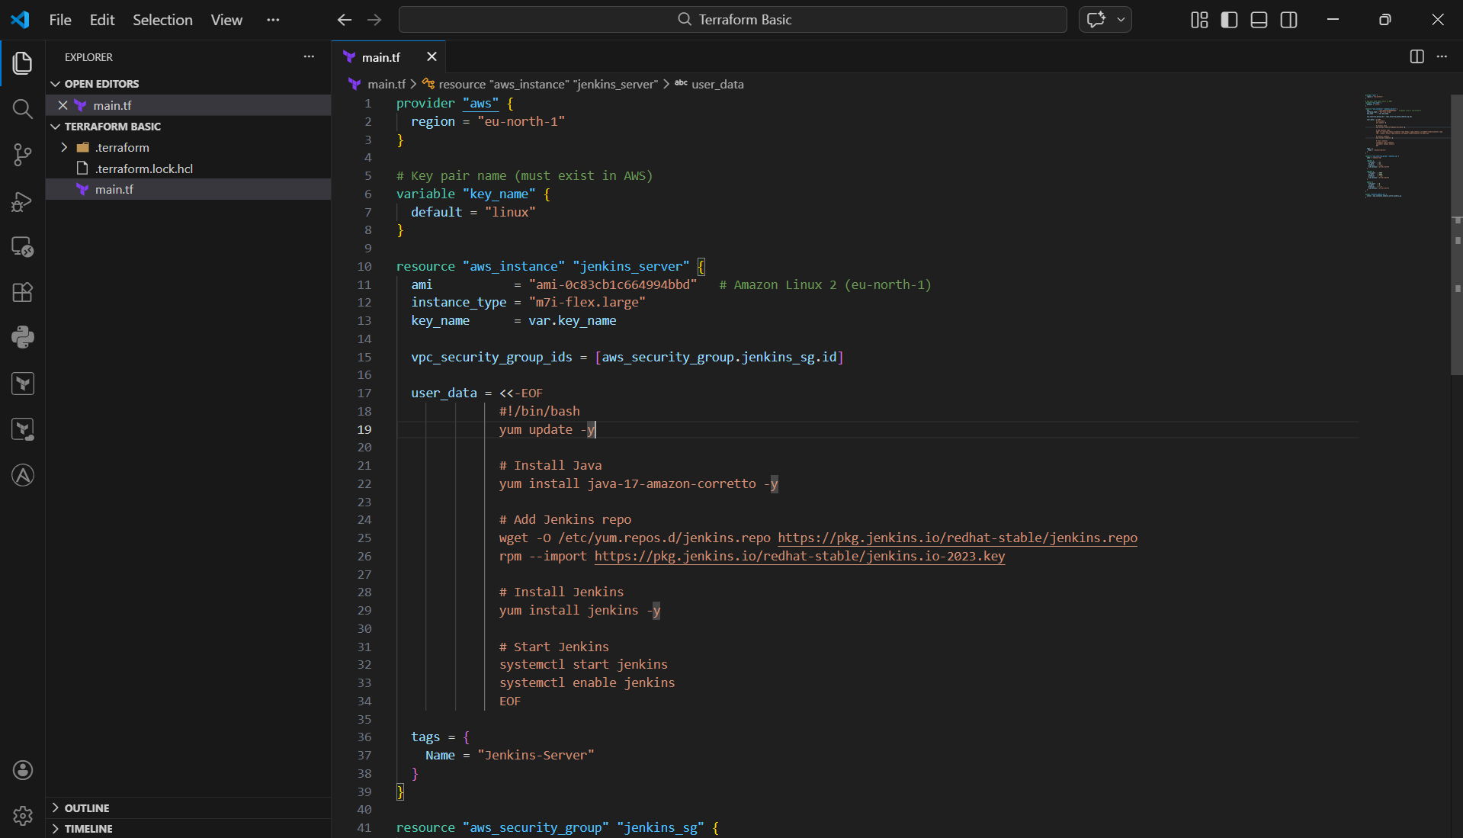

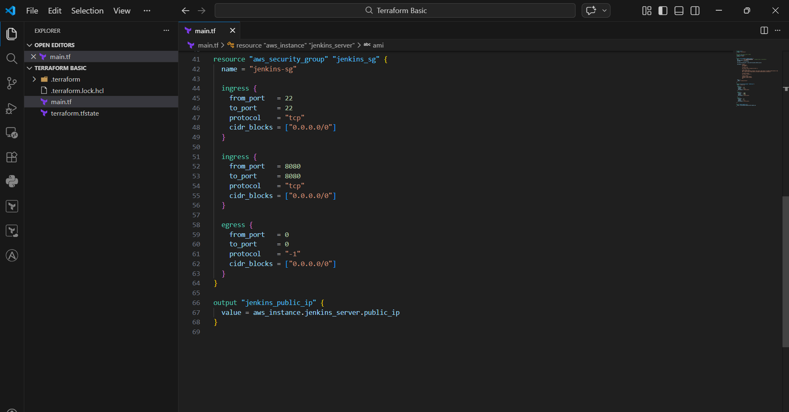

Configure AWS Credentials
In terminal, ran:
aws configure
And entered:
- Access Key
- Secret Key
- Region: eu-north-1
- Format: json
This connects Terraform to AWS.

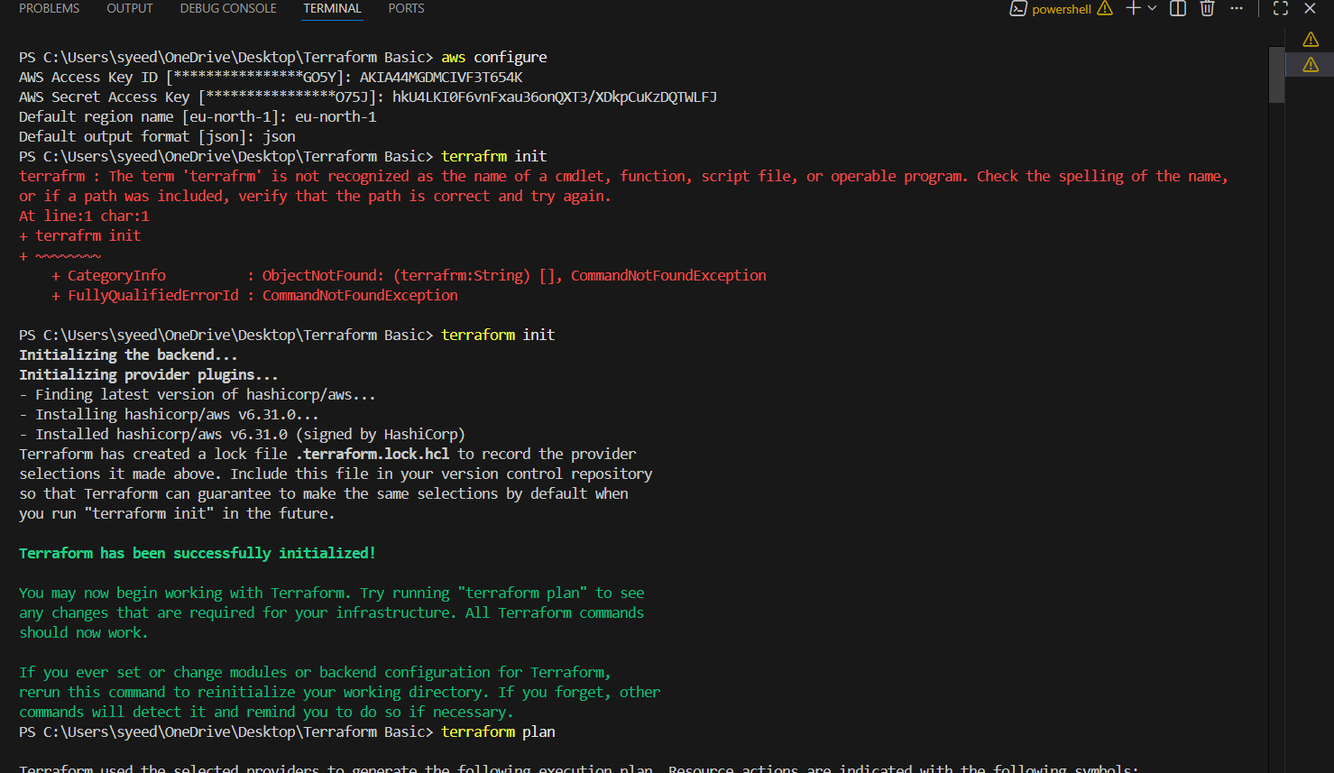
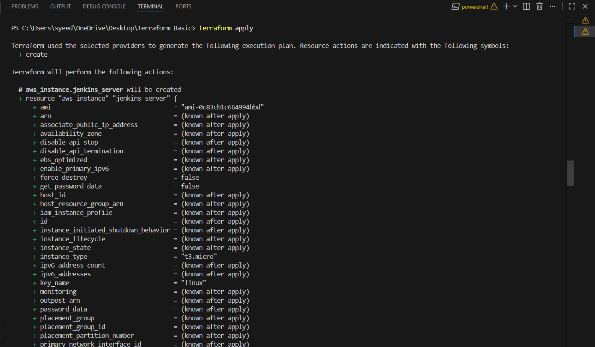
Get Public IP from Output
After apply, got:
jenkins_public_ip = 16.16.68.13

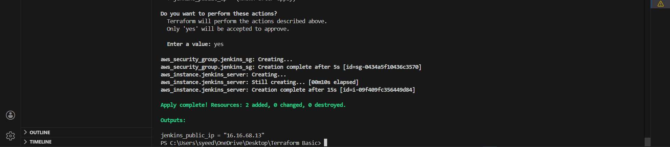
opened EC2 Dashboard and saw:
- Instance Name: Jenkins-Server
- Status: Running
- Public IP: 16.16.68.13
This confirms EC2 was created successfully.

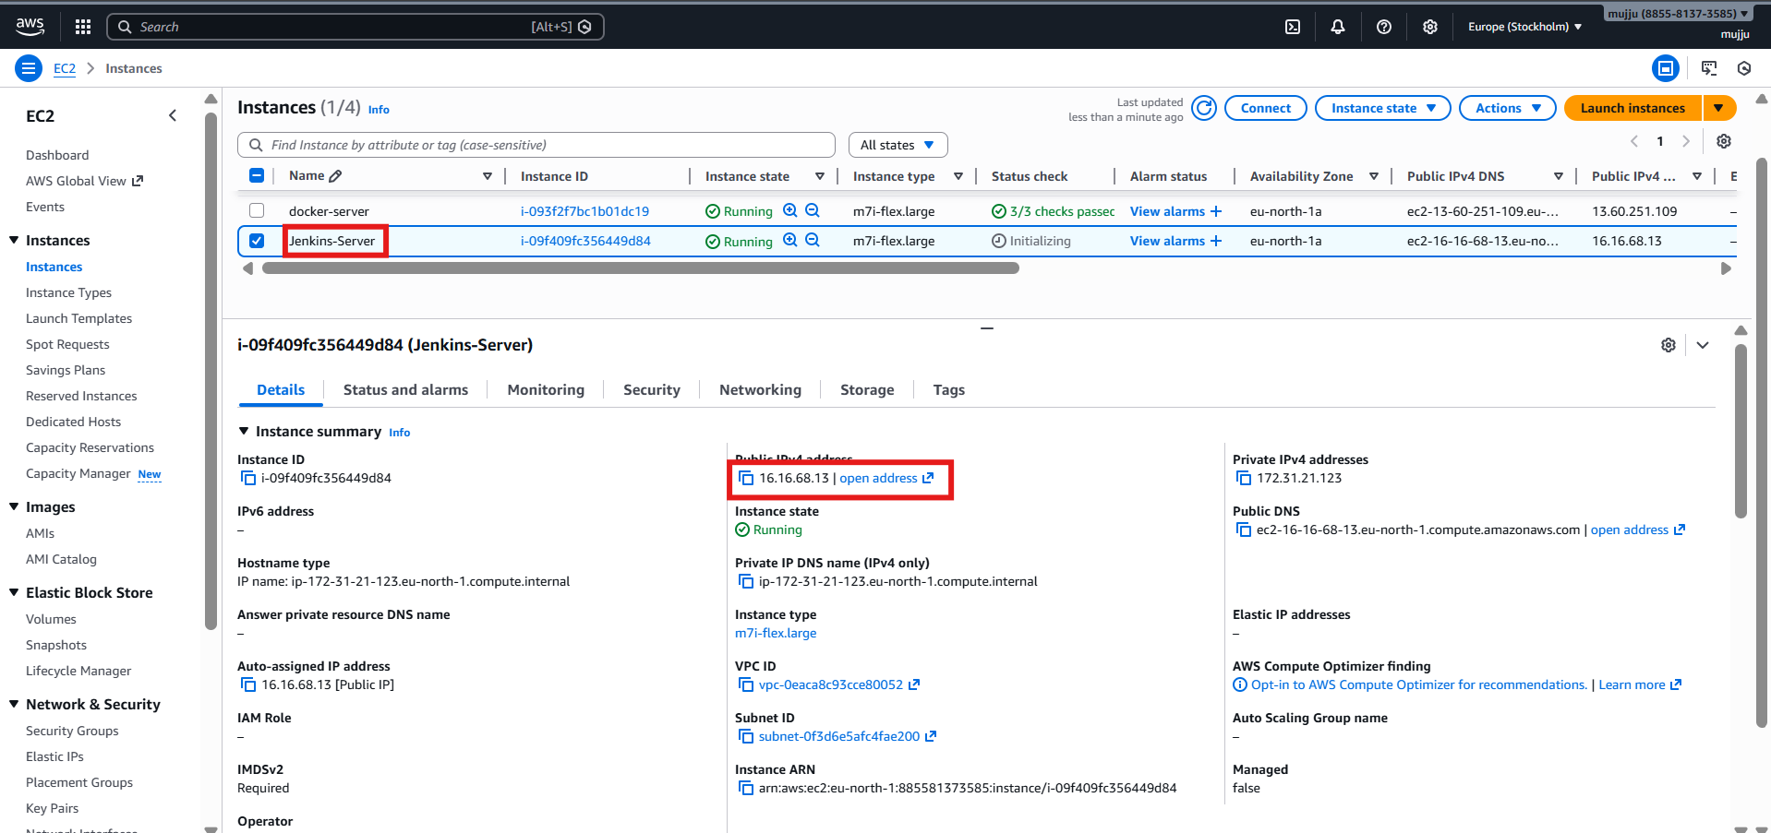
- Logged into Jenkins through intial admin password
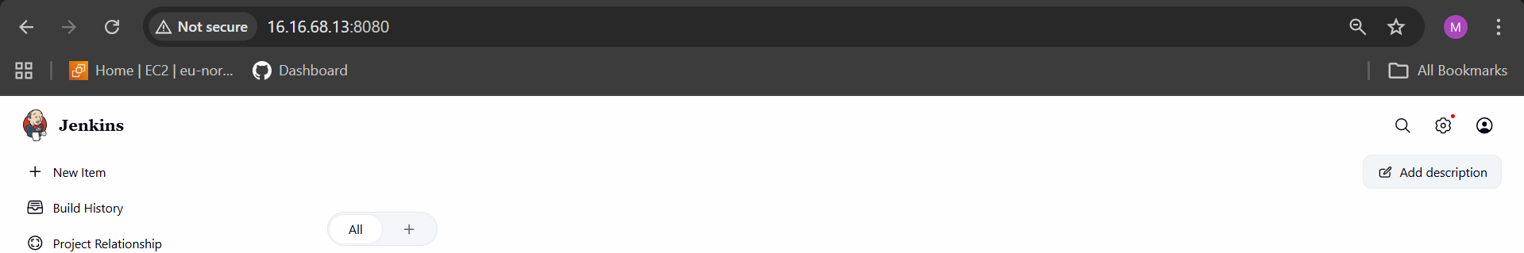

Create one Jenkins job to build and push the Docker image to Docker Hub.
- Source: https://github.com/betawins/Python-app.git
Install Git
- yum install git -y
Used for cloning GitHub repositories.

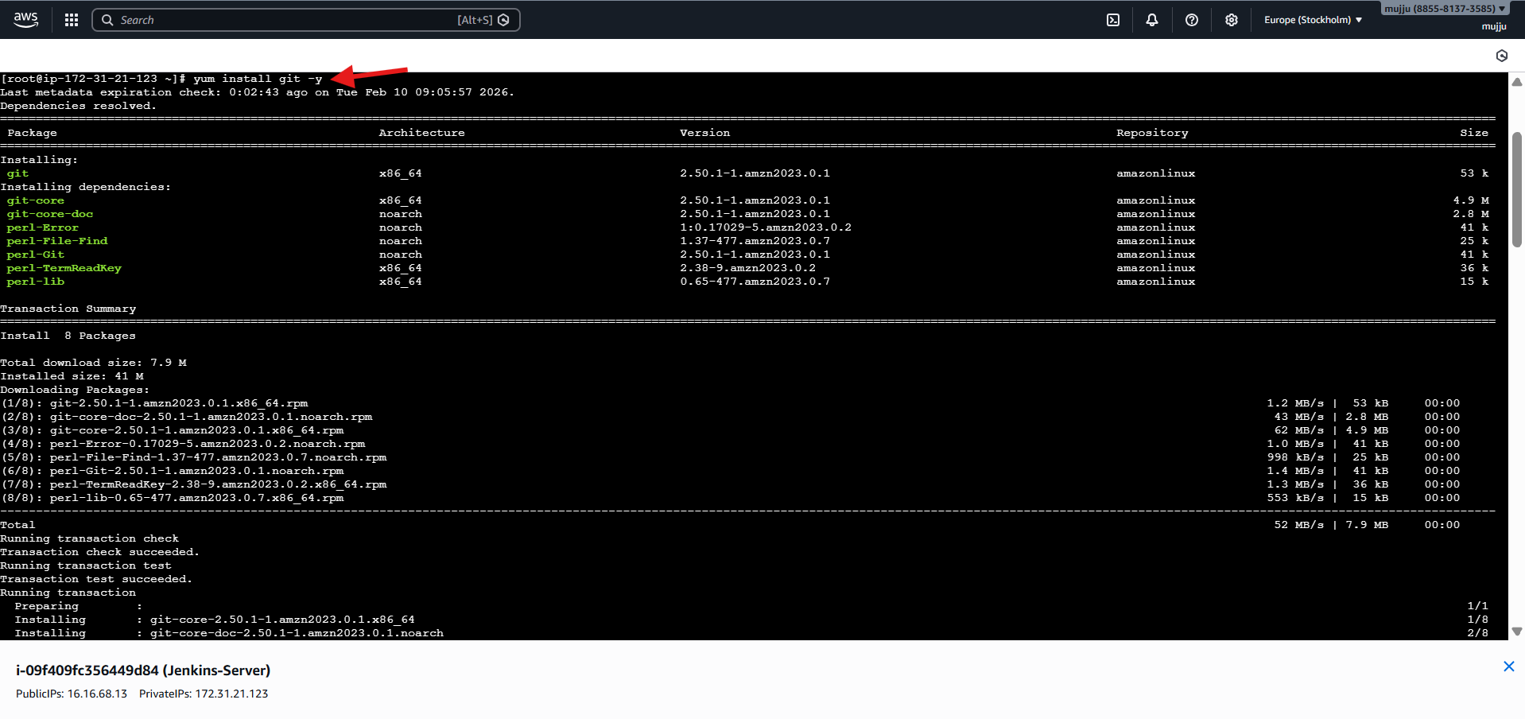
Install Docker
yum install docker -y
Installs Docker engine.

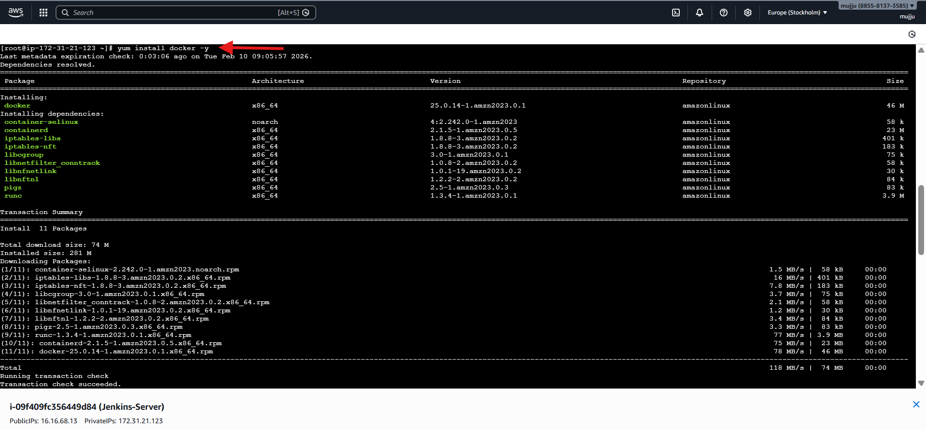
By default, Jenkins cannot run Docker commands. So you gave permission.
Add Jenkins User to Docker Group
- usermod -aG docker jenkins

Open Plugin Manager
Dashboard → Manage Jenkins → Manage Plugins → Available
Search and Install These Plugins
✔️ Docker
✔️ Docker Commons
✔️ Docker Pipeline
✔️ Docker API
✔️ Git Server

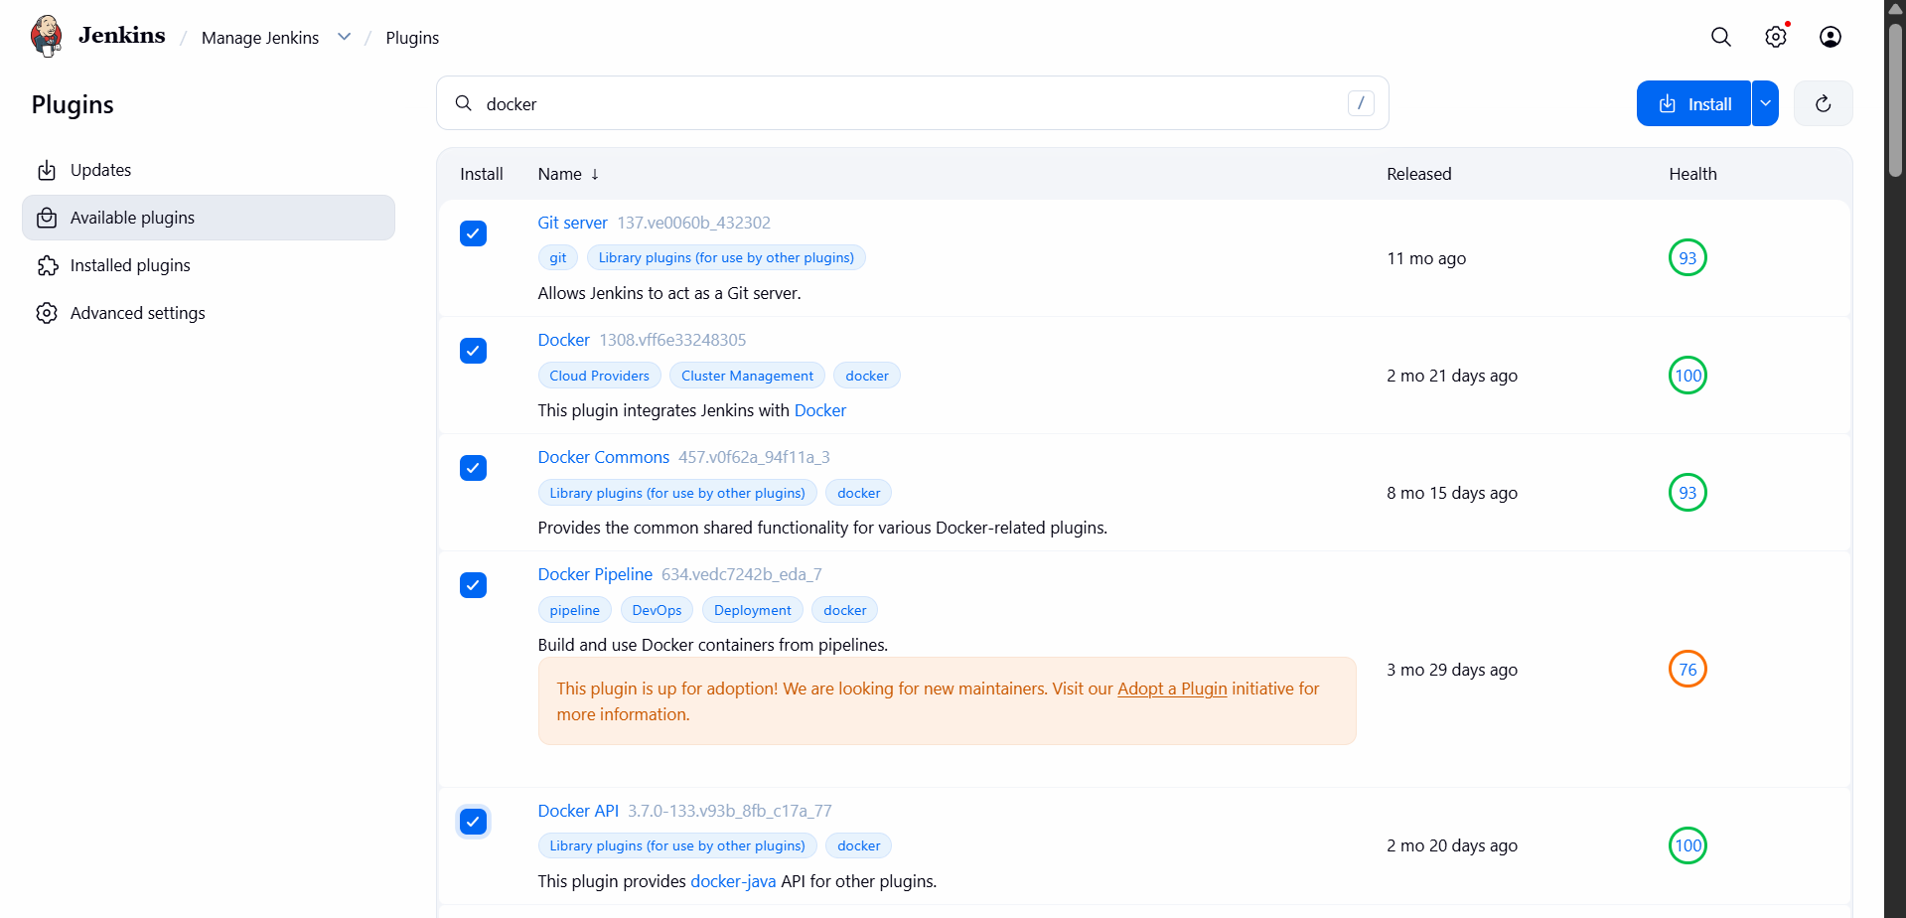
Open Credentials Page
Manage Jenkins → Credentials → System → Global → Add Credentials
Add Credentials
Fill:
Field | Value
Kind | Username & Password
Username | Docker Hub username
Password | Docker Hub password
ID | Docker
Description | Docker
Click Create.

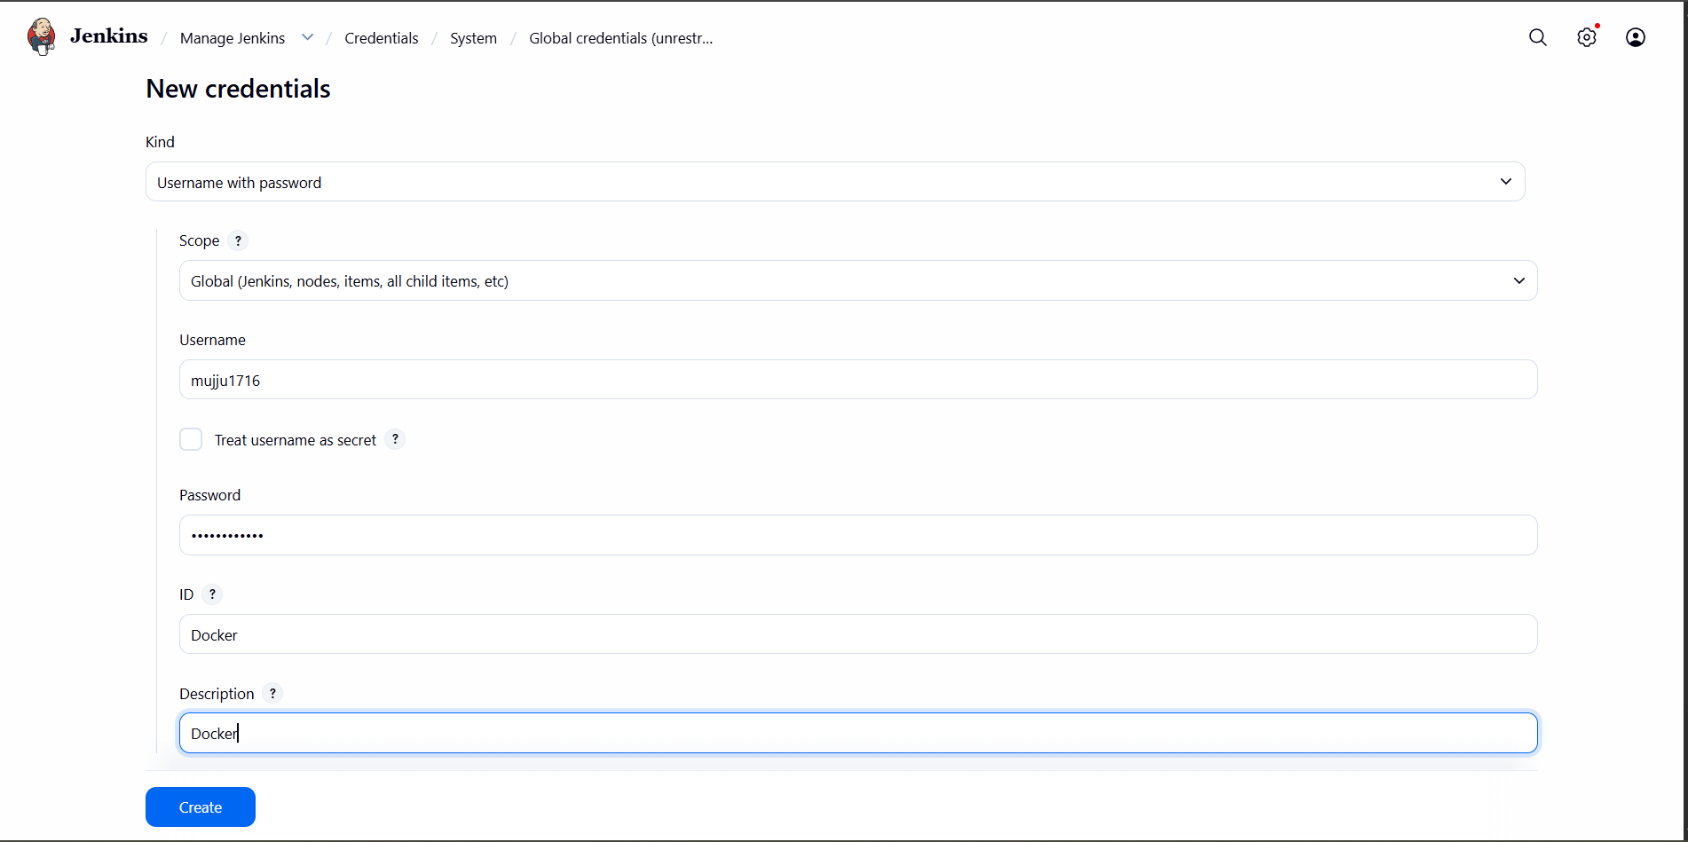
Create New Job
Dashboard → New Item
Enter Job Name
Docker-python
Select:
Pipeline
Click OK.

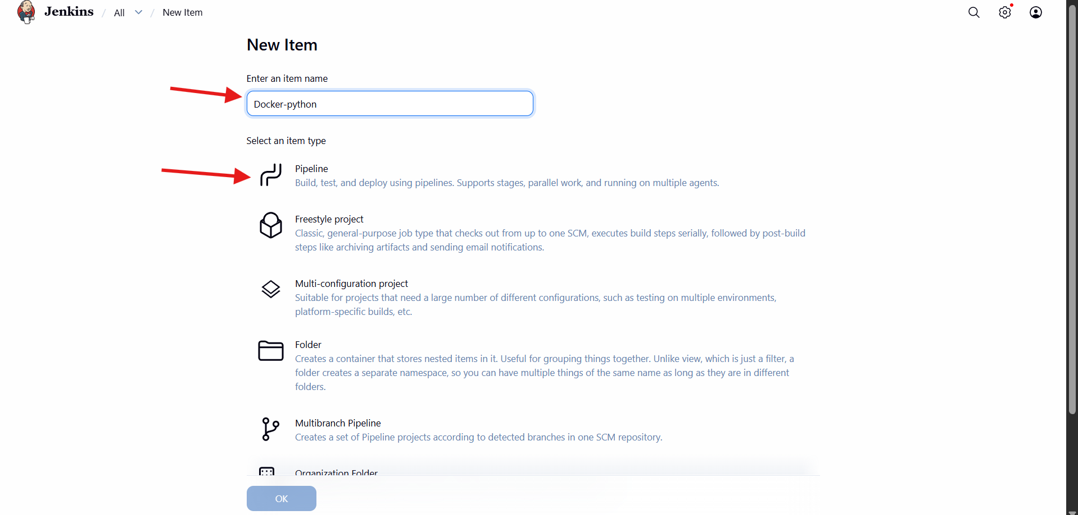
pipeline {
agent any
environment {
IMAGE_NAME = "mujju1716/python-app"
TAG = "v1"
}
stages {
stage('Checkout Code') {
steps {
git branch: 'main', url: 'https://github.com/betawins/Python-app.git'
}
}
stage('Build Image') {
steps {
sh 'docker build -t $IMAGE_NAME:$TAG .'
}
}
stage('Login to DockerHub') {
steps {
withCredentials([usernamePassword(
credentialsId: 'Docker',
usernameVariable: 'USER',
passwordVariable: 'PASS'
)]) {
sh 'echo $PASS | docker login -u $USER --password-stdin'
}
}
}
stage('Push Image') {
steps {
sh 'docker push $IMAGE_NAME:$TAG'
}
}
}
}
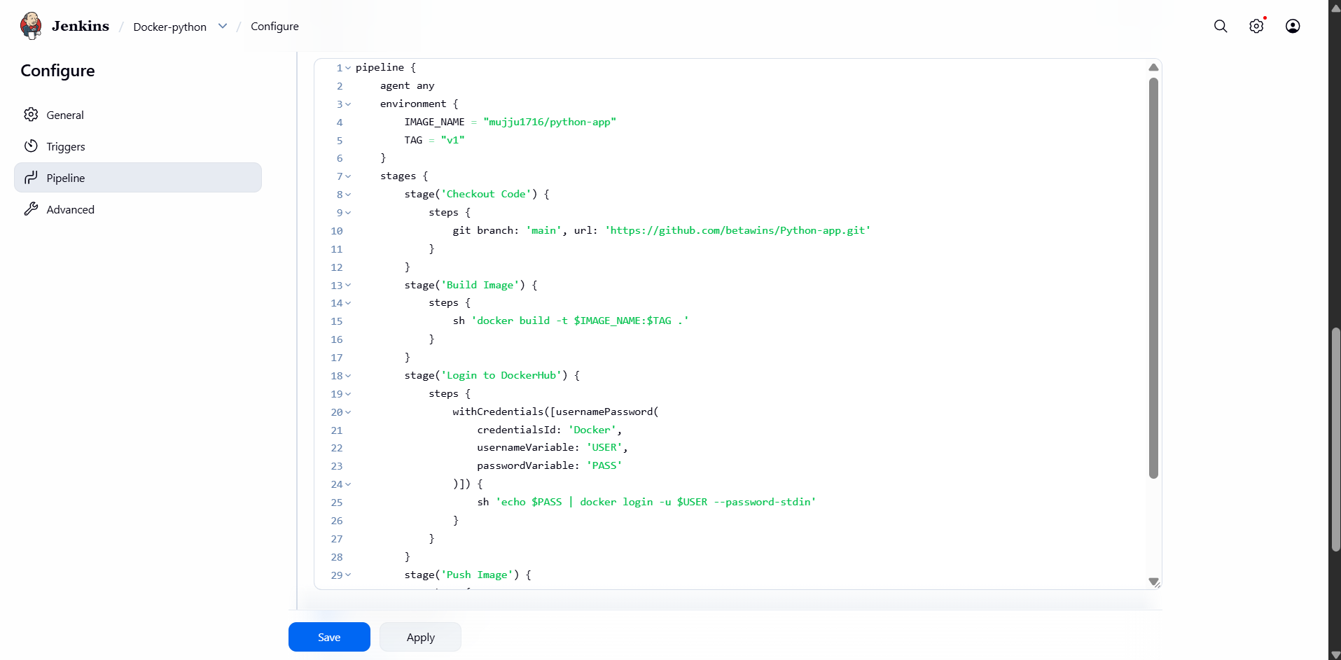
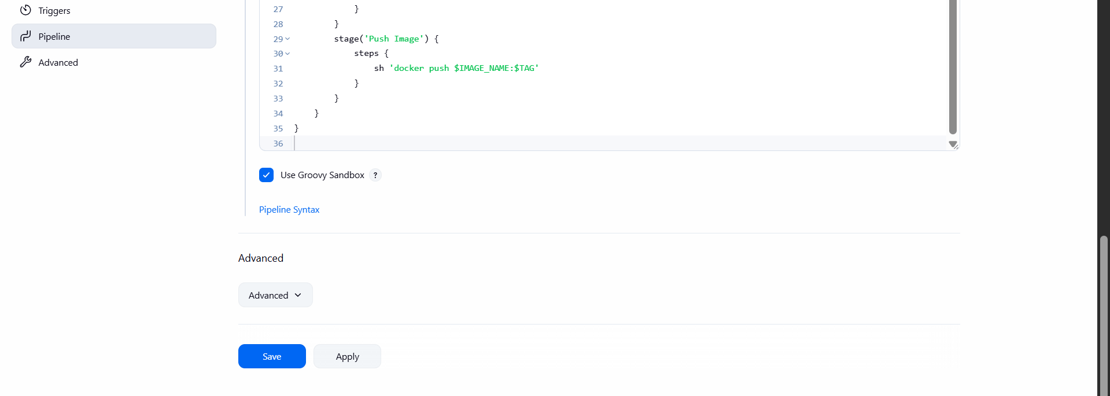
trigger Build
Click:
Build Now
14. Monitor Stages
You saw green stages:
✔️ Checkout Code
✔️ Build Image
✔️ Login to DockerHub
✔️ Push Image

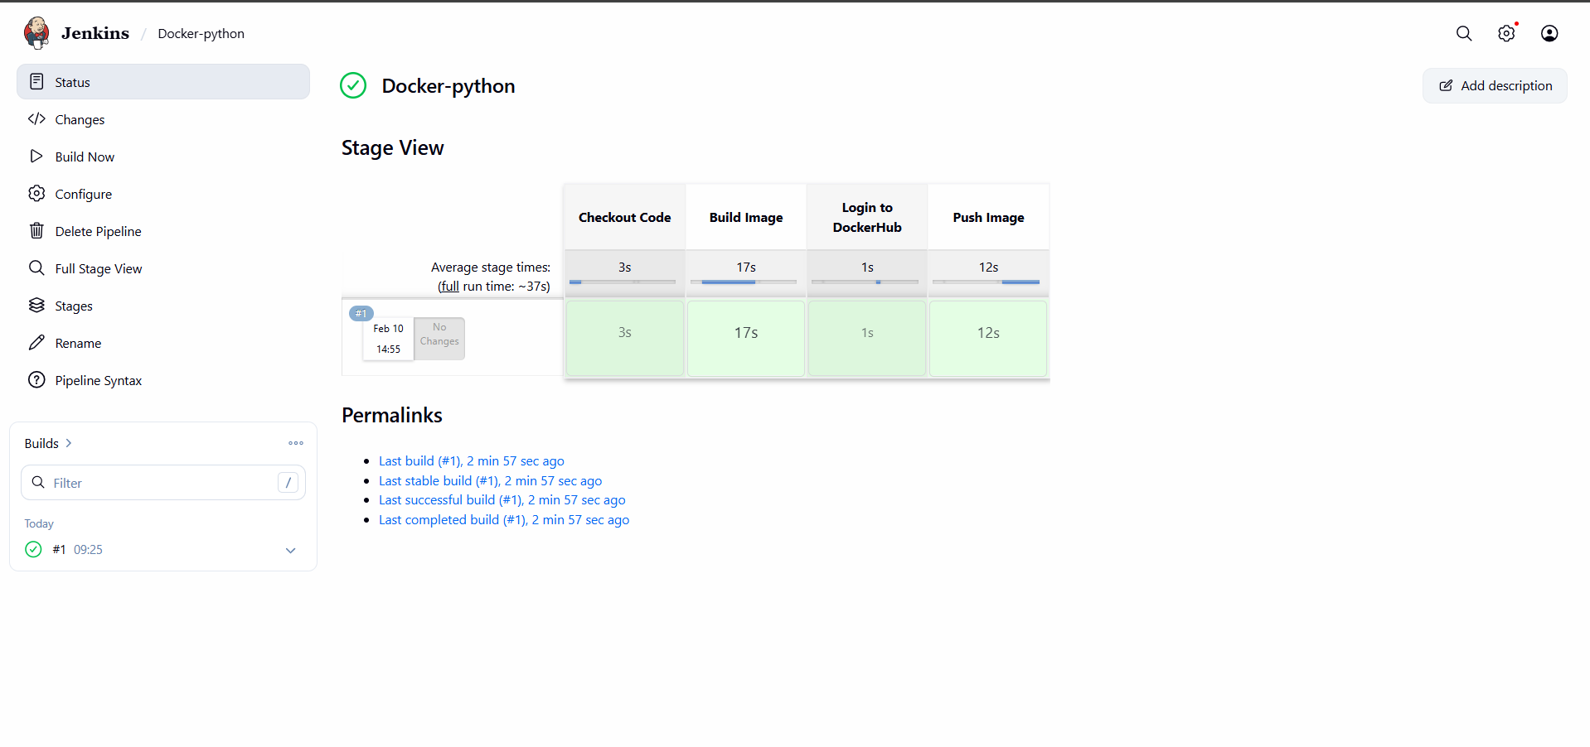
Open Docker Hub
logged in and checked:
Repositories → muju1716/python-app

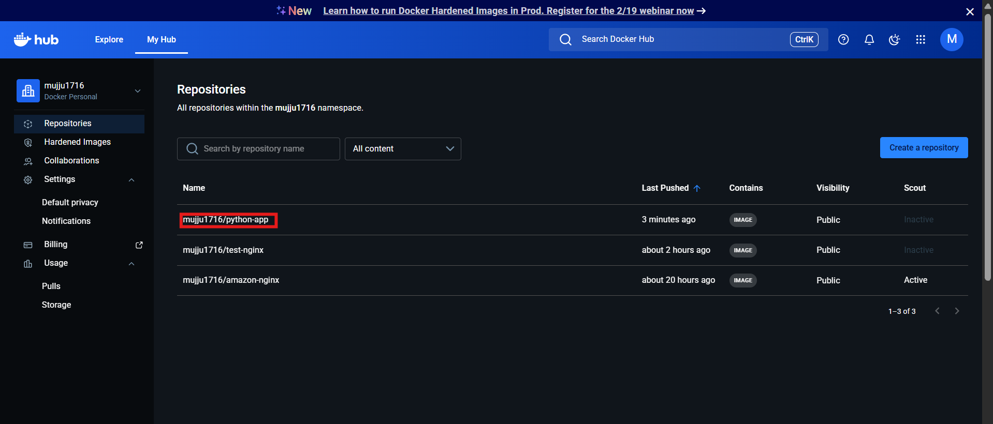

- Source Codes: https://github.com/betawins/docker-tasks.git
From the frontend source code, write a Dockerfile, build a Docker image, run it, and push that image to your Docker registry.

Create Project Folder
- mkdir source-code
- cd source-code

Clone GitHub Repository
- git clone https://github.com/betawins/docker-tasks.git

Navigate to Frontend Folder
- cd docker-tasks/Frontend_based_source
ls

create Dockerfile
- vi Dockerfile
Add Dockerfile Content

FROM nginx:alpine

COPY . /usr/share/nginx/html

EXPOSE 80

CMD ["nginx","-g","daemon off;"]

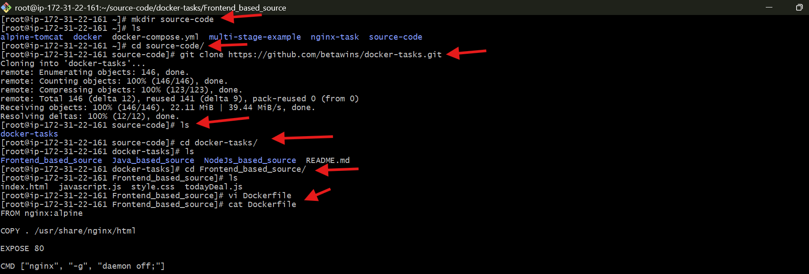
Build Image
- docker build -t muju1716/frontend-app

Run Container
- docker run -d -p 8085:80 --name frontend muju1716/frontend-app

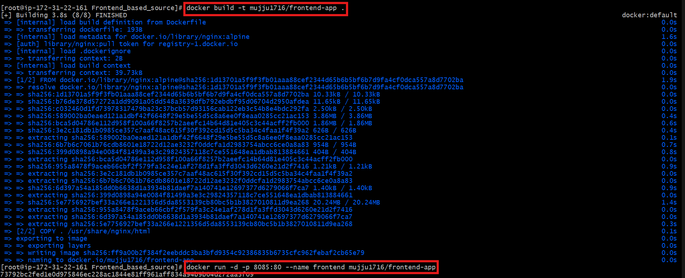
Access in Browser
Open:
http://<EC2-Public-IP>:8085

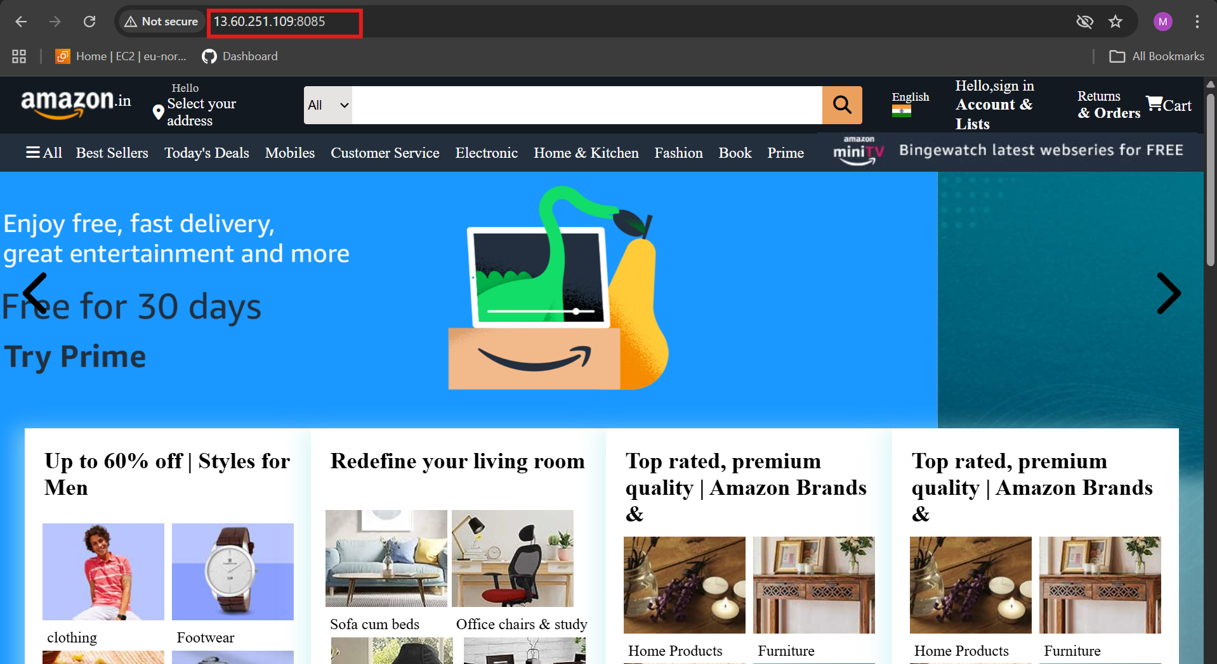

login to Docker Hub
- docker login

Push Image
- docker push muju1716/frontend-app
Image uploaded to Docker Hub.

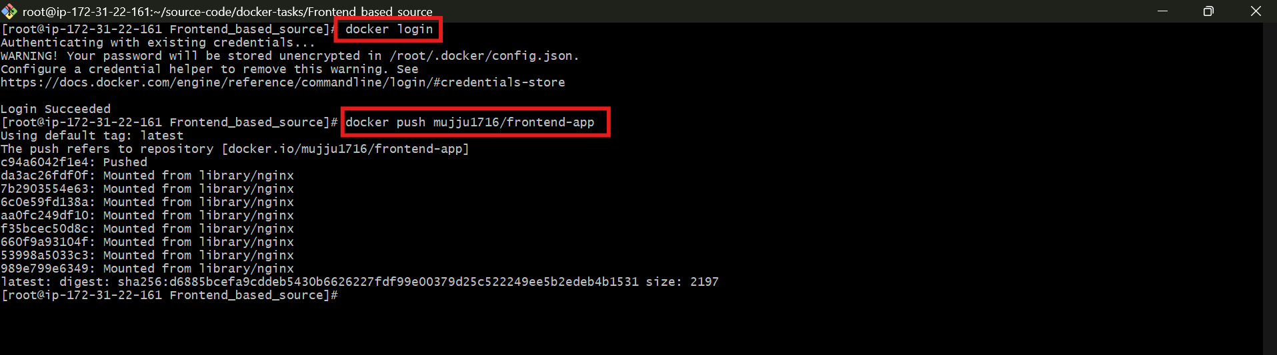
check Repository
verified:
muju1716/frontend-app

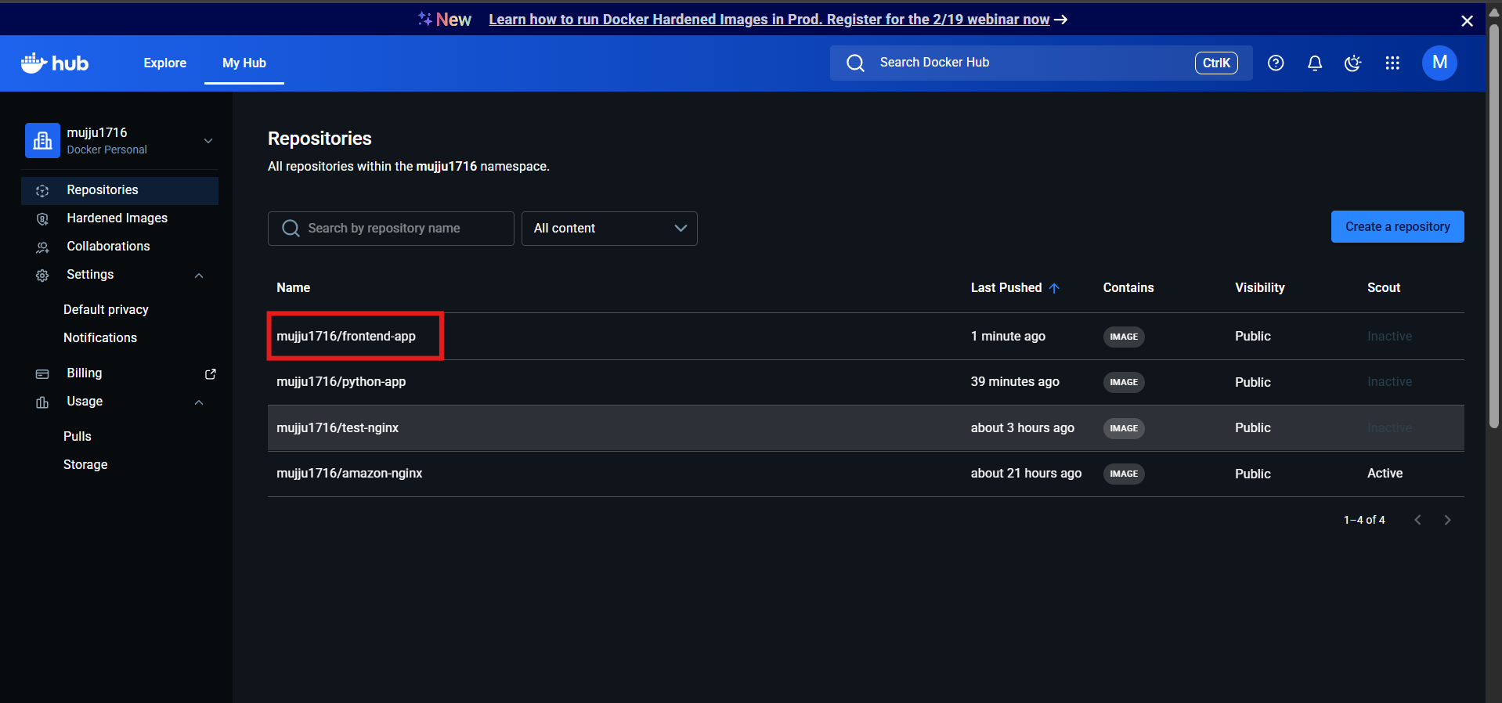
From the Java-based source code, write a Dockerfile, build, run, and push the image to the Docker registry.

Move to Java Source Folder
- cd /source-code/docker-tasks/Java_based_source
ls

Open Dockerfile
- vi Dockerfile

3. Add Dockerfile Content (Multi-Stage Build)
# Build stage
FROM maven:3.9.6-eclipse-temurin-17 AS build
WORKDIR /app
COPY . .
RUN mvn clean package -DskipTests

# Runtime stage
FROM eclipse-temurin:17-jre
WORKDIR /app
COPY --from=build /app/target/*.jar app.jar

EXPOSE 8080
CMD ["java","-jar","app.jar"]

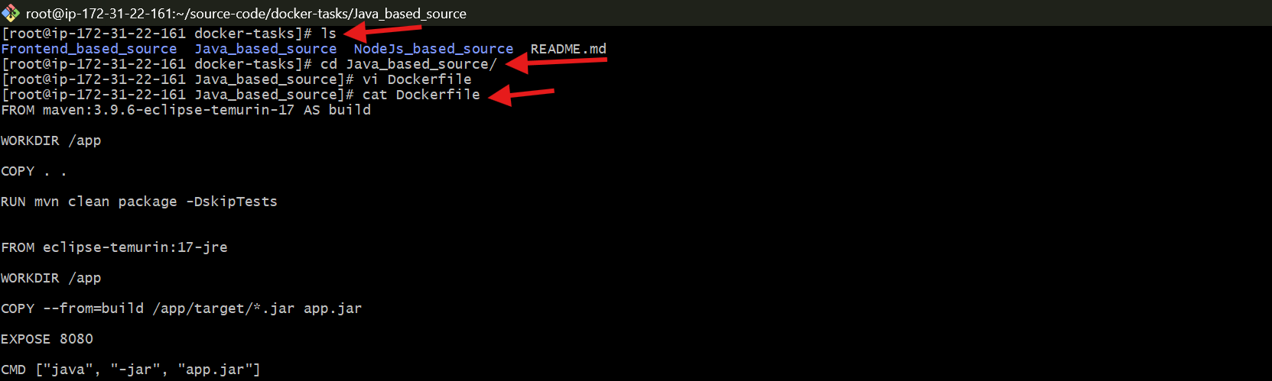
Build Image
- docker build -t muju1716/java-app .

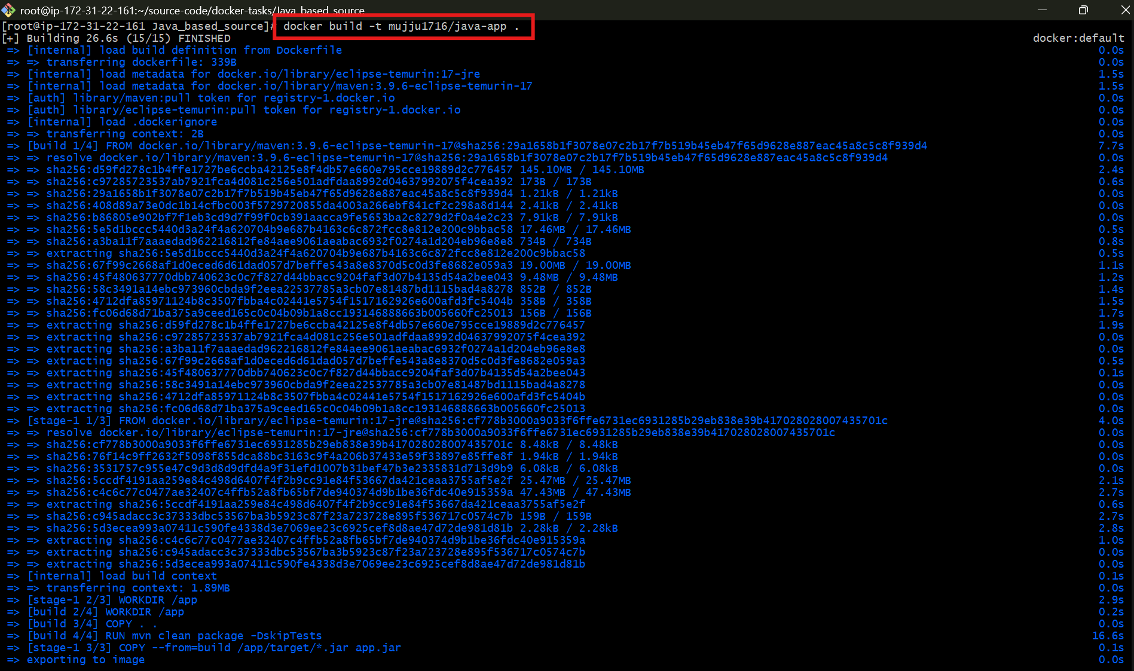

Run Container
- docker run -d -p 8086:8080 --name javaapp muju1716/java-app

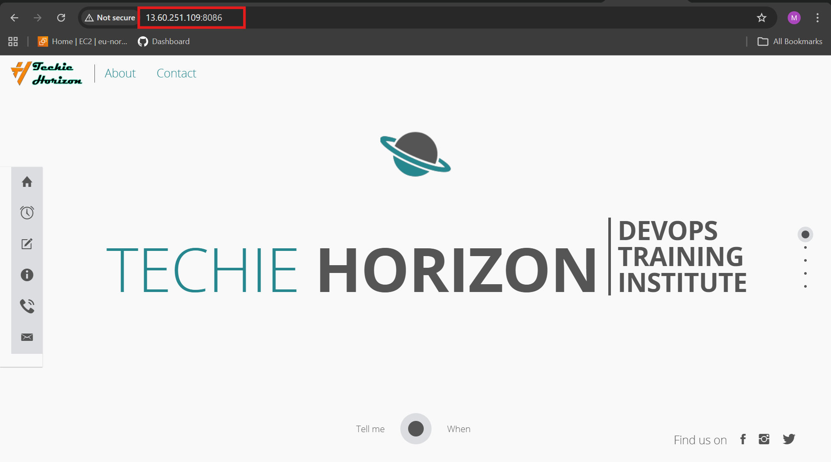
Login to Docker Hub
- docker login

Push Image
- docker push muju1716/java-app

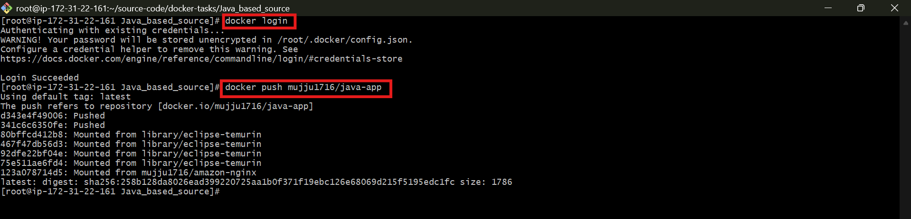

Check Repository
confirmed:
muju1716/java-app

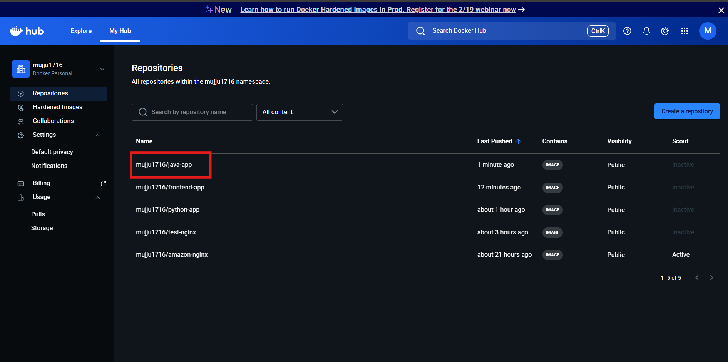

From the Node.js-based source code, write a Dockerfile, build with tag v1, run, and push it to the Docker registry.

Go to Node.js Project Directory
- cd /source-code/docker-tasks/NodeJs_based_source
ls

Create Dockerfile
- vi Dockerfile

Add Dockerfile Content

FROM node:18-alpine

WORKDIR /app

COPY package*.json ./

RUN npm install

COPY . .

EXPOSE 3000

CMD ["npm","start"]

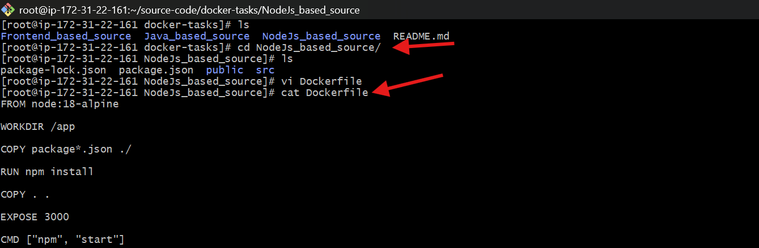
Build Image
- docker build -t muju1716/node-app:v1 .

Run Container
- docker run -d -p 8087:3000 --name nodeapp muju1716/node-app:v1

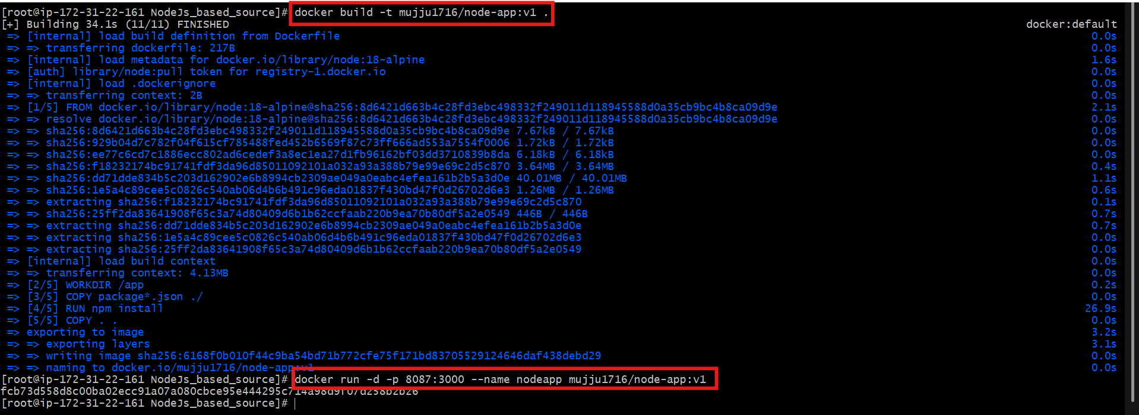
Open in Browser
http://<EC2-Public-IP>:8087


Login to Docker Hub
- docker login

Push Image
- docker push muju1716/node-app:v1

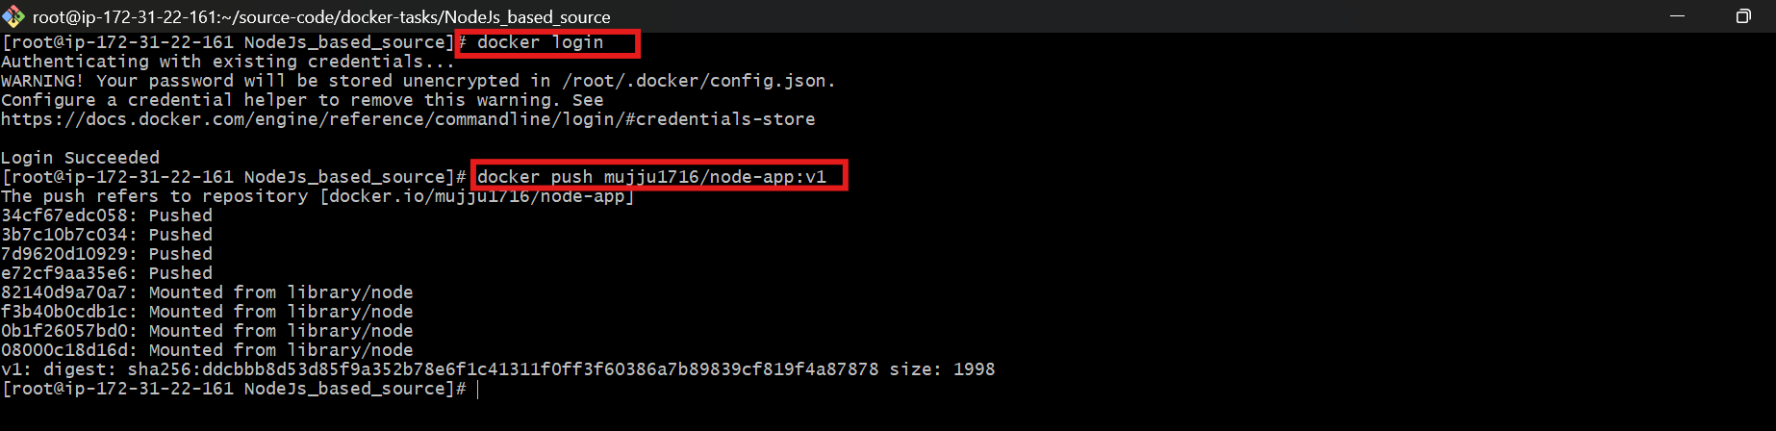

- Write a docker-compose file to set up WordPress with a MySQL database.
Create Working Directory
- mkdir wordpress-compose
- cd wordpress-compose

Create docker-compose.yml
- vi docker-compose.yml

Add Docker Compose Configuration
version: '3.8'

services:

db:
image: mysql:8
container_name: wordpress-db
restart: always
environment:
MYSQL_DATABASE: wordpress
MYSQL_USER: wpuser
MYSQL_PASSWORD: wppass
MYSQL_ROOT_PASSWORD: rootpass
volumes:
- db_data:/var/lib/mysql

wordpress:
image: wordpress:latest
container_name: wordpress-app
restart: always
depends_on:
- db
ports:
- "8090:80"
environment:
WORDPRESS_DB_HOST: db:3306
WORDPRESS_DB_USER: wpuser
WORDPRESS_DB_PASSWORD: wppass
WORDPRESS_DB_NAME: wordpress
volumes:
- wp_data:/var/www/html

volumes:
db_data:
wp_data:

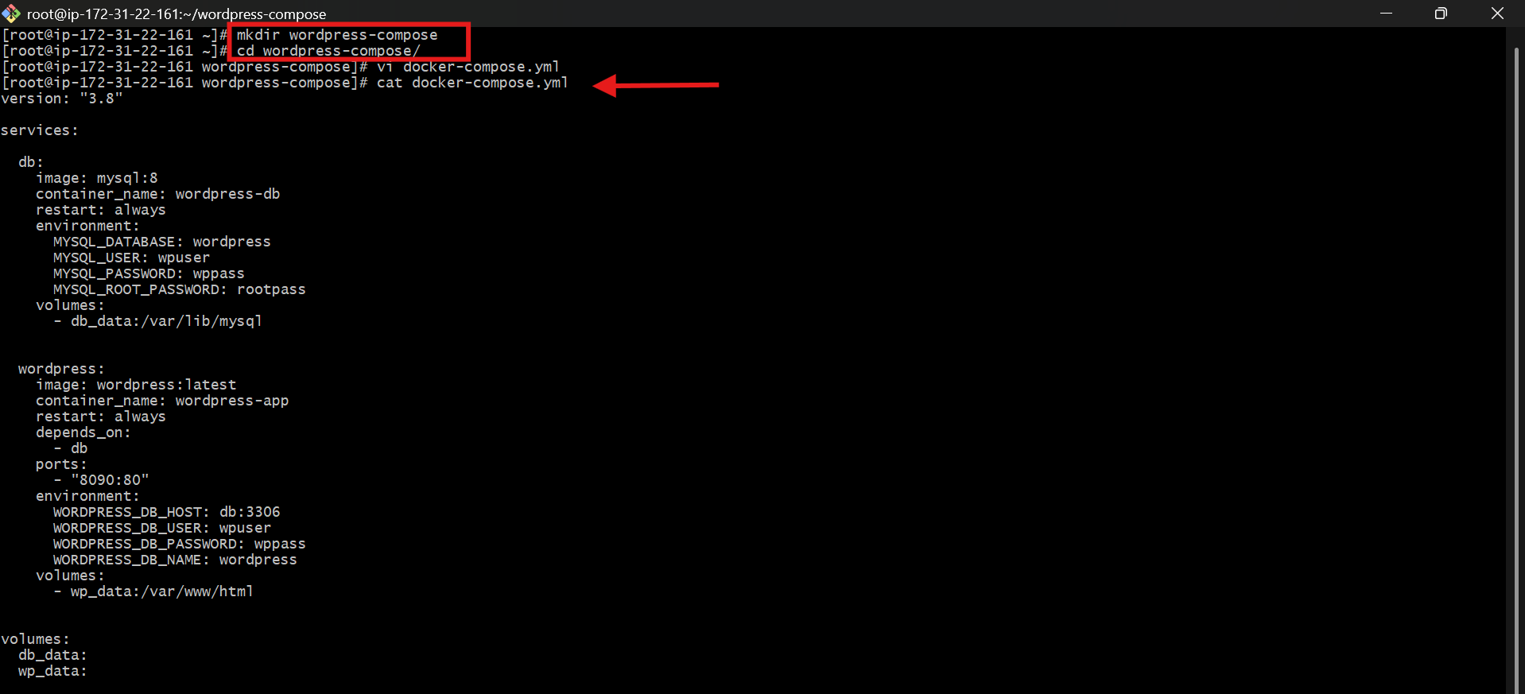
Launch Containers
- docker-compose up -d

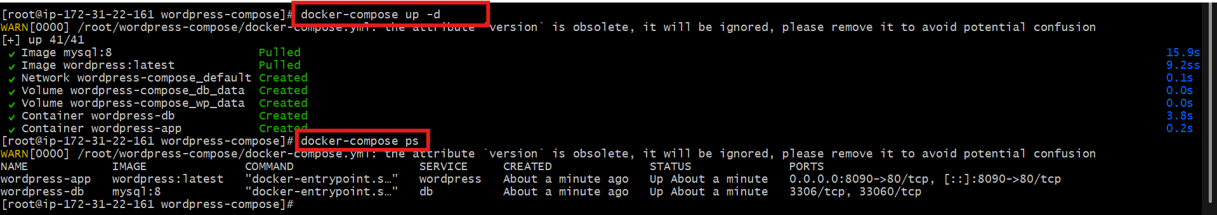

Open WordPress Setup Page
In browser, opened:
http://<EC2-Public-IP>:8090/wp-admin/install.php

